 | INSTITUTO SUPERIOR TÉCNICO  Departamento de Engenharia Informática  Forensics Cyber Security  MEIC / METI 2025-2026 – 1st Period

Digital Forensics Report Lab1
Group number: | 51 | Name | IST Number
Student 1: |  | Olha Buts | 116276
Student 2: |  | Vasco Conceição | 106481
Student 3: |  | Nuno Martins | 107273

Acquired artifacts
Name | Type | SHA-256 Value
zyra.csf.syssec.dpss.inesc-id.pt | folder | 3f0d4782e3631e1c2ea600603e000ee26330b3e12fe05631ab0187d62ec1abd9
recovered.pdf | pdf | 748e7358ccbba0b769b94ecb3c96c161fd8366454acf076a6f95b5f404515e1d
myzip password | string | 2d72db72c86887d5ec8cc3e5906e2a1a9120df36b4f639a88b11f83f6c85e608
blank.pdf | pdf | c8b046d0294d05d2d1402b5badcc4cef929cb1621d8e17b225fe27ee803d1a19
RaceCar_hidden.png | png | 934a3652117143b0cef5d9ff6161ee943efc5cde987ca770f6181aca9abc28e5
MingleGame_hidden.db | database | 23108d6552bbd633ed80c3de50449e0698294c0da3a049a61bbaed41e0edcea0
fst-gang_hidden.png | png | 00b650b7a00e509701e3991e1556dc898d879b356c08220a16803e1bef9aacf3

Report of all findings
The first step of our investigation was scanning the QR code on the flyer, which directed us to the site:
http://zyra.csf.syssec.dpss.inesc-id.pt:80/public
By removing /public, we discovered that we could access the site’s files directly. We then downloaded all the files using the following command:
wget --mirror --page-requisites --convert-links --adjust-extension --no-parent \ --wait=1 --limit-rate=200K --user-agent="Mozilla/5.0 (X11; Linux x86_64)" \ -P ./localcopy http://zyra.csf.syssec.dpss.inesc-id.pt/
By searching within the site’s resources folder, we discovered seven secrets hidden among the available files — four were files (2 PDFs and 2 PNGs), two were hidden messages that look like code, and one was a password. The following sections describe these findings in detail.
- Hidden Database in MingleGame.wav
- What we found:
The file MingleGame.wav was initially recognized as an audio track. When played, it contained the song “Mingle Game Song” from Squid Game. However, further analysis revealed that the WAV file also had an embedded SQLite database.

- How we found it (steps & commands):
- Extracted strings:
strings MingleGame.wav > ../../Outputs/MingleGame.wav.txt
(keep in mind all output files are saved in Outputs folder, we won’t write ../../Outputs every time)
- The strings output exposed fragments of an SQLite header (SQLite format 3), table names, and schema information. To properly recover the database, we developed and ran a custom Python script (GetDBChunk.py). This script extracted the hidden SQLi chunk, repaired the truncated header by prepending the missing bytes, and wrote the repaired file to: Outputs/MingleGame_hidden.db
python3 GetDBChunk.py
- Within the extracted SQLite database, the table licensors shows ID’s corresponding to licensors:
sqlite3 MingleGame_hidden.db
SELECT * FROM licensors;
SELECT * FROM zones;
SELECT * FROM parking_transaction;
SELECT * FROM testers;

- Findings:
The recovered SQLite database (also visible in the strings output saved to Outputs/MingleGame.wav.txt) contained the header (SQLite format 3), table schemas, and multiple records. The database included the following tables:
- parking_transaction — fields: id, plate, country, licensor_id, zone_id, date, time, duration, price
- testers — list of license plates registered as testers
- zones — mapping between licensor IDs and zone capacities (each licensor operates a given zone with a defined size/capacity).
- licensors — mapping between licensor IDs and names
Analysis of the contents revealed several irregularities:
- Insider exemptions: Plates listed in the testers table (e.g., OG-83-YN, CT-27-TL, NA-11-MQ) appear in the parking_transaction table with price = 0.0.
- Inflated charges for foreign vehicles: Multiple transactions involving foreign or rental plates (e.g., MW398ZQ from Italy, B-UU 4157 from Germany, 3516-PGM from Spain) were reassigned to licensor_id 217, which corresponds to Futuro Inteligente Lda., and charged inflated prices compared to Portuguese plates in the same zones.
- Ghost zone allocation: The zones table shows that licensor 217 operates in zone 18, which has a suspiciously low value (10) compared to other legitimate zones (e.g., Colombo with 6300, Vasco da Gama with 3000).
These findings provide a direct data-level confirmation of the manipulations uncovered in the code fragments: insiders were exempted from payment, while foreign/rental vehicles were overcharged, and all such manipulated revenue was routed through licensor ID 217 (Futuro Inteligente Lda.).

- Concealed PDF Invoice in steghide
- What we found:
The file steghide contained Base64-encoded data which, once decoded, revealed a PDF invoice.

- How we found it (steps & commands):
- Checked metadata:
exiftool steghide
- Inspected bytes:
hexdump -C steghide
- Extracted Base64 strings:
strings steghide | grep -E '^[A-Za-z0-9+/=]{20,}' > steghide_base64_dump.txt
- Verified decoding of first line:
head -n 1 steghide_base64_dump.txt | base64 -d | xxd | head
- Decoded full content:
base64 -d steghide_base64_dump.txt > auxPdf.pdf
- Recovered PDF:
xxd -r -p auxPdf.pdf > recovered.pdf

- Findings:
The document, issued by Futuro Inteligente Lda. to client MEMEL, shows two billed services (consulting and office leasing) totaling €255,771.61. The invoice includes taxpayer number, client reference, and a due date of 2024-09-30. This finding confirms the concealment of financial documents within disguised files.
Both the hidden SQLite database in MingleGame.wav and the concealed PDF invoice in steghide point to Futuro Inteligente Lda., linking operational records with financial documentation from the same entity.
- Password from myzip.zip
- What we found:
A password-protected ZIP archive, which we cracked using a custom wordlist.
- How we found it (steps & commands):
1. Extracted the ZIP hash:
zip2john myzip.zip > zip_hash.txt
- Built a targeted wordlist from Modern_Cars.pdf:
pdftotext Modern_Cars.pdf pdf_words.txt
- Ran John the Ripper with the wordlist:
john --wordlist=pdf_words.txt --rules zip_hash.txt
- Displayed the discovered password:
john --show zip_hash.txt
- Findings:
The recovered password was: iftheconsumptionratecannotbesignificantlyreduced.
After opening the archive with the recovered password, the files found inside the ZIP were:
- 222.jpg
- 456.jpg
- blank
- fst-gang.png

- Altered File Type in blank
- What we found:
Inside the ZIP archive, a file named blank was disguised. It turned out to be a PDF with a corrupted PNG header.

- How we found it (steps & commands):
1. Verified file type:
file blank
2. Inspected header:
hexdump -C blank | head -n 8
- Corrected header:
sed -i '1s/^%PNG-1.4/%PDF-1.4/' blank
- Verified again:
file blank
- Open the recovered PDF for viewing:
xdg-open blank
(also saved a copy of blank.pdf in the Outputs folder)

- Findings:
After correction, the file opened as a three-page PDF titled Financial Annual Report 2024 for MEMEL.
- Vendors: largest expense to Futuro Inteligente, Lda. (€789,269.60).
- Leasing: offices at Câmara Municipal de Lisboa (€860,000), Centro Comercial Colombo, Estádio da Luz, Hotel Sheraton.
- Revenue: €25M from parking fines (citizens €19.5M, tourists €3M, other mobility €2.5M).

- Embedded code patches in image metadata (BarragemFagilde.tiff & BarragemOdelouca.jpg)
- What we found:
Two image files contained binary-encoded text in their metadata which, once decoded, revealed code fragments (diff/patch-style instructions) that modify parking transaction logic.
At first glance, looked suspicious on the “User Comment” metadata: it was a string with no spaces, and only made of dots and dashes. We thought it could be morse code but because it had no spaces, we thought it would be hidden binary content. So, we made a script to translate that string to binary code. Then, with the binary content, we translated to ASCII

- How we found it (steps & commands):
  - Inspect images metadata:
exiftool BarragemFagilde.tiff > BarragemFagilde.tiff.txt
exiftool BarragemOdelouca.jpg > BarragemOdelouca.jpg.txt
  - Extract suspicious string fields and convert from binary (BinaryDecoder custom script used)
python3 BinaryDecoder.py barragemFagilde
python3 BinaryDecoder.py barragemOdelouca
(BarragemOdelouca custom script sets an offset of 4 when translating from binary)

- Findings (decoded content):
BarragemFagilde.tiff — decoded output contained a diff/patch fragment:
155d154
< # advanced rule 1
< tester_plates = load_tester_plates_from_db()
< if current_transaction.plate in tester_plates:
< current_transaction.price = 0.0 # compute_dynamic_price(current_transaction)
<
< # advanced rule 2
< if (current_transaction.pl
Interpretation of the decoded lines: the fragment is formatted as a standard diff instruction (155d154) with surrounding code context that shows a rule setting current_transaction.price = 0.0 for plates listed as tester_plates.
BarragemOdelouca.jpg — decoded output (after applying a decoding offset = 4) contained a code fragment that changes pricing for certain plates:
te_country != "PT" or is_plate_from_rental_company(current_transaction.plate)) and random.random() < 0.5:
< current_transaction.licensor_id = 217
< current_transaction.price = round(compute_dynamic_price(current_transaction) * random.uniform(1.5, 2), 2)
<
>
This fragment shows code that (for non-PT or rental plates, with a probabilistic condition) reassigns licensor_id and multiplies the computed price by a random factor between 1.5 and 2. The use of standard diff/patch notation indicates that these lines were marked for deletion from the original source code.

- Hidden Image Analysis — RaceCar.png
- What we found:
By extracting the LSB data from RaceCar.png, we uncovered a concealed PNG image (RaceCar_hidden.png). The hidden image is a Reddit screenshot showing a discussion thread titled “Street Parking question” from r/lisboa. The conversation highlights random and unfair parking price fluctuations in Lisbon, with several users complaining that tourists often pay more than locals for the same spots.

- How we found it (steps & commands):
We used the custom script ZigZagExtractLSB.py, which is specifically designed to extract data hidden through Least Significant Bit (LSB) steganography following a non-linear, zig-zag traversal of pixels. The script reads the 4 least significant bits of each pixel channel, reconstructs them into bytes, and outputs the hidden binary stream. In this case:
- Running the script on RaceCar.png produced RaceCar_hidden.bin:
python3 ZigZagextractLSB.py
- Checking its header with xxd revealed the PNG magic number:
xxd RaceCar_hidden.bin | head -n 10
- Renaming the file to RaceCar_hidden.png recovered the hidden Reddit screenshot:
mv RaceCar_hidden.bin RaceCar_hidden.png

- Findings:
The hidden Reddit screenshot directly reinforces the anomalies uncovered in the manipulated system code and transaction database: it shows real-world user complaints that mirror the fraudulent logic — locals being favored, tourists being charged more. This concealed evidence further links the technical manipulations to their perceived effects in practice. Metadata analysis also revealed that the image was authored in Canva by Laura Cunha and created on 2025-09-06, confirming that the concealment of this evidence was deliberate and recent.
- Hidden Image Analysis — fst-gang.png
- What we found:
Inside the myzip.zip archive, the file fst-gang.png contained hidden data. Extracting it revealed a concealed PNG (fst-gang_hidden.png) showing a WhatsApp group chat titled Smart Parkinator.

- How we found it (steps & commands):
We used zsteg to analyze possible steganographic encodings within the PNG. Specifically, the following command was executed:
zsteg fst-gang.png -E b3,rgb,lsb,xy > fst-gang_hidden.png

- Findings:
The recovered image (fst-gang_hidden.png) is a WhatsApp screenshot showing participants Adelino Estoiro, Alcíbiades Mourato, Duarte Calado, Eurico Trocos, Hermínio Gaiolas, and João Zé das Tabelas. In the chat, members discuss ensuring exemptions are correctly applied and avoiding complaints from foreign plates. One participant (Alcíbiades Mourato) explicitly requests that his plate MC-95-QN be added to the “exemption list.”

Based on your analysis, did you find evidence of this being a scam? If so, describe the nature of this scam and provide technical details on how it was conducted.
Yes, the analysis uncovered clear evidence of a scam.
The recovered code in BarragemFagilde.tiff shows that tester plates were exempted by setting their transaction price to 0.0, while code in BarragemOdelouca.jpg reassigns the licensor_id to 217 (Futuro Inteligente Lda.) and applies a random multiplier between 1.5 and 2 to foreign or rental plates.
An embedded SQLite database inside MingleGame.wav contains parking transaction records (plates, dates, times, Lisbon locations) consistent with these manipulations. The testers table includes MC-95-QN, the same plate mentioned in a WhatsApp screenshot that refers to an “exemption list,” confirming a match between the database and the chat. This same plate is verifiably present in the testers table, confirming the link between the chat and the database records. The same chat also includes instructions to be discreet, confirming that participants were aware of the fraudulent nature of their activities. This establishes a direct connection between the concealed system data and real-world coordination of the scam.
Concealed financial documents — a decoded invoice and an annual report — both reference Futuro Inteligente Lda. and list €25M in fine revenues, directly linking the manipulated transactions to this organisation. In addition, a Reddit screenshot hidden in RaceCar.png shows users publicly complaining about unfair parking charges in Lisbon, confirming that the manipulated pricing was experienced in practice.
Technical details:
The scam was carried out by altering the application logic to implement differential pricing rules:
- Testers (exemption list) → exempt, transactions forced to free (price = 0.0). Example: tester plate OG-83-YN appears in transactions with price = 0.0, consistent with both the database and the WhatsApp chat reference to “exemption list.”
- Foreign/Rental plates → reassigned to licensor ID 217 (Futuro Inteligente Lda.) and charged inflated prices (price × 1.5–2.0), e.g.: foreign plate MW398ZQ (Italy) was reassigned to licensor_id 217 and overcharged.
The operational data and financial paperwork were deliberately concealed using multiple techniques:
- a SQLite database blob hidden in a WAV audio file,
- Base64-encoded PDFs embedded in other files,
- password-protected ZIP archives,
- altered file headers to disguise content,
- LSB steganography in images.
Together, these artifacts — once extracted and decoded using forensic tools — demonstrate deliberate programmatic manipulation combined with systematic concealment of logs and financial evidence. The corroborating public complaints and explicit WhatsApp coordination confirm the scam’s real-world impact.

Additional scam (credential harvesting via login page):
Analysis of the login.html and backend JavaScript code revealed a fraudulent login mechanism. The frontend form posts credentials to /login, but instead of validating them, the backend appends the submitted email and password to a local file (credentials.txt). Immediately after saving, the system redirects the user to /public and displays a generic error popup, giving the impression of a failed login attempt.
Technical flow:
- User submits credentials → Server writes Email and Password to credentials.txt → User is shown a fake “Something went wrong” popup.
This confirms that the platform was also used for phishing-style credential harvesting, complementing the parking manipulation scam.

Did you uncover any additional concealed artifacts during your investigation? If so, explain how these artifacts were hidden and describe the methodology you used to extract them.
Yes. As described in detail in Report of all Findings, several additional concealed artifacts were uncovered, each hidden using different obfuscation or steganographic methods:
- MingleGame.wav (Secret 1): Contained an embedded SQLite database (header SQLite format 3), which stored parking transactions including licence plates, dates, times, and Lisbon locations.
- steghide (Secret 2): Contained Base64-encoded content that, once decoded, produced a PDF invoice issued by Futuro Inteligente Lda..
- myzip.zip / blank (Secrets 3 and 4): A password-protected archive that, once cracked, revealed a disguised file blank. Although its header mimicked a PNG, correcting it revealed a 3-page PDF (Annual Report 2024 for MEMEL).
- BarragemFagilde.tiff and BarragemOdelouca.jpg (Secret 5): Contained binary-encoded text in metadata, which decoded to code patches manipulating parking prices (tester plates → free; foreign/rental plates → reassigned licensor_id 217 (Futuro Inteligente Lda.) + surcharge).
- RaceCar.png (Secret 6): Concealed another PNG via zig-zag LSB steganography. The recovered Reddit screenshot showed public complaints about unfair parking pricing in Lisbon.
- fst-gang.png (Secret 7): The image fst-gang.png extracted from myzip.zip contained a hidden WhatsApp group screenshot, recovered through zsteg command we mentioned above. This image shows participants explicitly discussing the use of an “exemption list” (plates such as MC-95-QN), which directly corresponds to the testers table in the hidden SQLite database.

With a focus on the additional concealed secrets you recovered, analyze their content and relationships, and propose a possible interpretation of their meaning. Formulate a hypothesis regarding their significance and support it with the content of the recovered secrets. Additionally, prepare a timeline of the events suggested by these recovered materials.
Content and relationships
- BarragemFagilde.tiff: Code fragment exempting “tester” plates (price = 0.0).
- BarragemOdelouca.jpg: Code fragment inflating charges for foreign/rental plates by reassigning licensor_id to 217 (Futuro Inteligente Lda.) and applying a price multiplier.
- MingleGame.wav: Embedded SQLite database logging manipulated parking transactions, licence plates, timestamps, and Lisbon locations, with records pointing to licensor ID 217.
- The database contents confirm that plates listed in testers were exempted (price = 0.0), while foreign plates were rerouted to licensor_id 217, consistent with the code fragments.
- The zones table reveals a suspicious “ghost zone” (zone 18, capacity 10) linked only to Futuro Inteligente Lda.
- fst-gang.png: Recovered WhatsApp group image. In that chat, insiders explicitly discussed adding plates such as MC-95-QN to avoid charges — and this exact plate is verifiably present in the testers table of the database. The conversation also includes reminders to “be discreet,” showing direct awareness of the fraudulent nature of these exemptions.
- steghide: PDF invoice issued by Futuro Inteligente Lda. to client MEMEL.
- blank.pdf (from myzip.zip): Financial Annual Report 2024 showing €25M revenue from fines and significant vendor payments to Futuro Inteligente Lda.
- RaceCar.png: Hidden Reddit screenshot with user complaints about unfair parking prices, reflecting the exact anomalies caused by the manipulated logic.
The relationship is clear: altered system code → biased transactions in the database → concealed financial documents consistently naming Futuro Inteligente Lda. → corroboration by public complaints.
Hypothesis
These materials collectively indicate a structured scheme. Tester plates (insiders) were exempted through the “exemption list,” while foreign/rental vehicles were overcharged. Transaction data was covertly logged, insiders coordinated plate additions and secrecy via WhatsApp, and supporting financial documents were hidden but traceable to Futuro Inteligente Lda. (licensor ID 217). The hypothesis is that this organisation orchestrated the manipulation, benefiting both from insider exemptions and inflated revenues disguised within official accounting.
Timeline suggested by recovered materials
- Code fragments (BarragemFagilde.tiff, BarragemOdelouca.jpg): Introduction of rules exempting insiders and inflating charges for foreign/rental plates.
- steghide invoice (2024-09-01, due 2024-09-30): Early financial documentation linking revenues to Futuro Inteligente Lda.
- blank.pdf Annual Report 2024: Consolidated yearly results with €25M in fine revenues and vendor payments to Futuro Inteligente Lda.
- MingleGame.wav database (transactions dated 2025-08-15, 15:09–17:59): Direct operational evidence that the manipulated rules were actively applied. One recovered record —
3214 | MC-95-QN | PT | 204 | 5 | 2025-08-15 | 17:09 | 16 | 0.0 — shows plate MC-95-QN exempted with price = 0.0.
- WhatsApp screenshot (00:04–00:07, prior to 2025-08-15): Conversation where insiders explicitly discuss adding MC-95-QN to the “exemption list” and warn each other to be discreet. This confirms coordination of exemptions before the database record was created.
- RaceCar_hidden.png Reddit screenshot (metadata creation date: 2025-09-06; Reddit thread marked “1 month ago”): Concealed evidence of public complaints about unfair parking charges, directly corroborating the manipulated logic.
Interpretation
The timeline shows the scam beginning with code modifications, financially supported through invoices and the 2024 Annual Report, then actively operating by mid-2025, and ultimately drawing public suspicion visible in user complaints. The concealment of these materials across formats (WAV, images, Base64, ZIP, steganography) demonstrates an intentional effort to hide both technical and financial evidence of the scheme, with Futuro Inteligente Lda. at its centre. The recovered WhatsApp group conversation further confirms insider coordination.

  - Did you find evidence of the identity of those responsible for this scam? Based on your findings, what recommendations would you make for the next steps in the investigation? Advise Prof. Alexandre Magno on the best course of action moving forward.
Evidence of identity
The recovered artifacts consistently reference the entity Futuro Inteligente Lda., and multiple pieces of evidence point directly to individuals coordinating the scheme.
- In the embedded SQLite database (MingleGame.wav), licensor ID 217 (Futuro Inteligente Lda.) is linked to manipulated transactions and a suspicious ghost zone (zone 18, capacity 10).
- Concealed documents (the invoice from steghide and the annual report from blank.pdf) show substantial revenues and vendor payments involving Futuro Inteligente Lda.
- A WhatsApp group conversation (“Smart Parkinator”) explicitly shows coordination of the scam by named individuals. Participants include:
  - Adelino Estoiro
  - Alcibiades Mourato
  - Duarte Calado
  - Eurico Trocos
  - Hermínio Gaiolas
  - João Zé das Tabelas
In this chat, insiders discuss managing the “exemption list” (which corresponds directly to the testers table in the database) and adding specific plates such as MC-95-QN, which is verifiably present in the testers table. They also caution each other to be discreet, confirming their awareness of the fraudulent nature of these exemptions.
Together, this establishes a direct connection between:
- The manipulated system logic (code fragments from BarragemFagilde.tiff and BarragemOdelouca.jpg),
- Operational data (SQLite database transactions),
- Financial records (invoice and annual report naming Futuro Inteligente Lda.), and
- Personal coordination (WhatsApp chat with explicit instructions and names).
Recommendations / Next steps
- Attribution and corroboration
  - Cross-reference Futuro Inteligente Lda. with official company records (registration, directors, tax filings).
  - Investigate the named WhatsApp participants (Adelino Estoiro, Alcibiades Mourato, Duarte Calado, Eurico Trocos, Hermínio Gaiolas, João Zé das Tabelas) to establish roles, affiliations, and links to the company.
  - Correlate license plates mentioned in the chat with registered vehicle owners and the plates present in testers table of the database.
- Technical forensics
  - Analyze transaction records by plate, zone, and licensor to quantify the scope of manipulated exemptions and overcharges.
  - Validate all decoded code fragments to confirm alignment with database manipulations.
- Financial investigation
  - Audit the invoices and annual report against external accounting and banking data.
  - Verify the claimed €25M revenue against municipal financial records.
- Evidence management and escalationw
  - Preserve all recovered evidence (database, PDFs, images, WhatsApp chat) with cryptographic hashes and chain of custody.
  - Escalate to law enforcement and fraud regulators, emphasizing the linkage between the company and identifiable individuals.
Advice to Prof. Alexandre Magno
The best course of action is to escalate immediately. The evidence demonstrates a coordinated scam involving both an organizational entity (Futuro Inteligente Lda.) and named individuals (Adelino Estoiro, Alcibiades Mourato, Duarte Calado, Eurico Trocos, Hermínio Gaiolas, João Zé das Tabelas) who explicitly discussed manipulating exemptions and stressed secrecy. In parallel, the testers table provides a concrete list of plates to be investigated, as identifying the registered owners will directly tie benefits to specific insiders.

Appendices
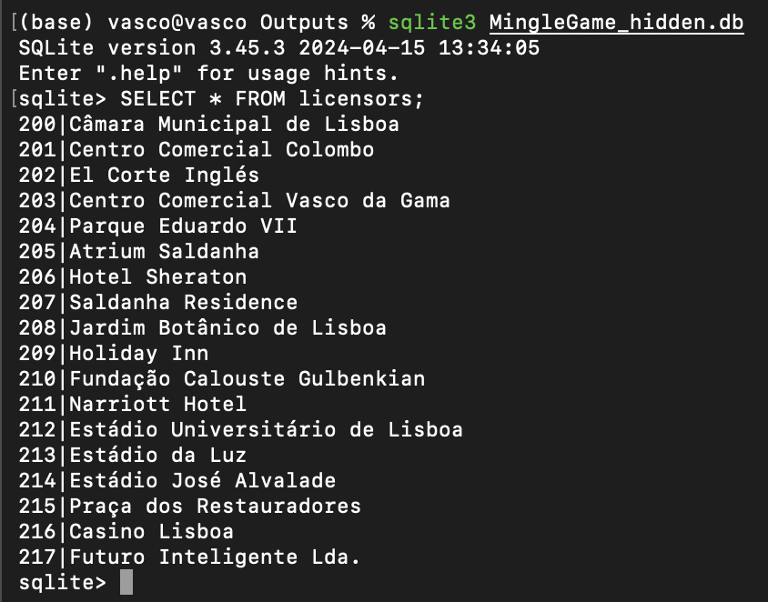
Figure 1 — licensors table extract

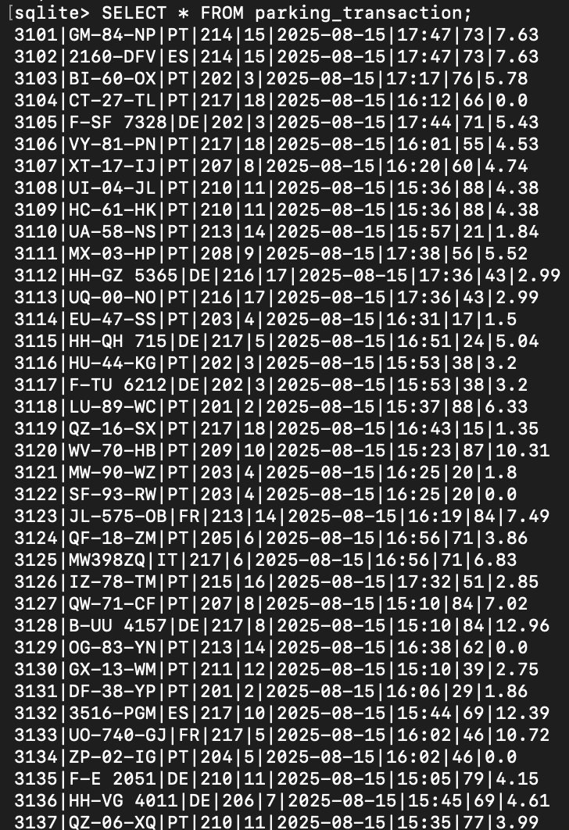
…
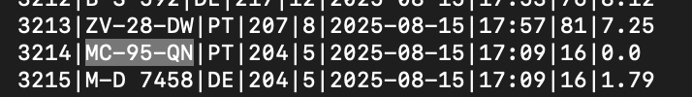

Figure 2 — transactions table extract

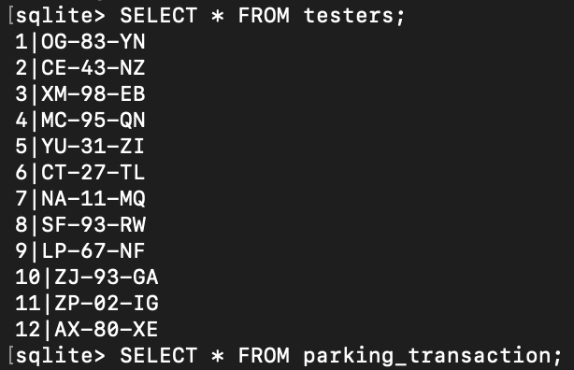
Figure 3 — testers table extract

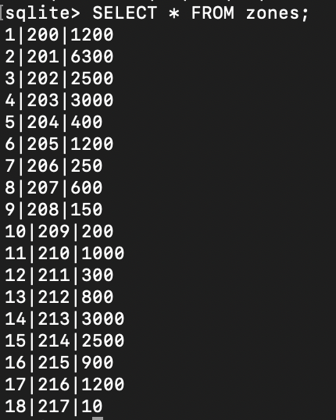
Figure 4 — zones table extract

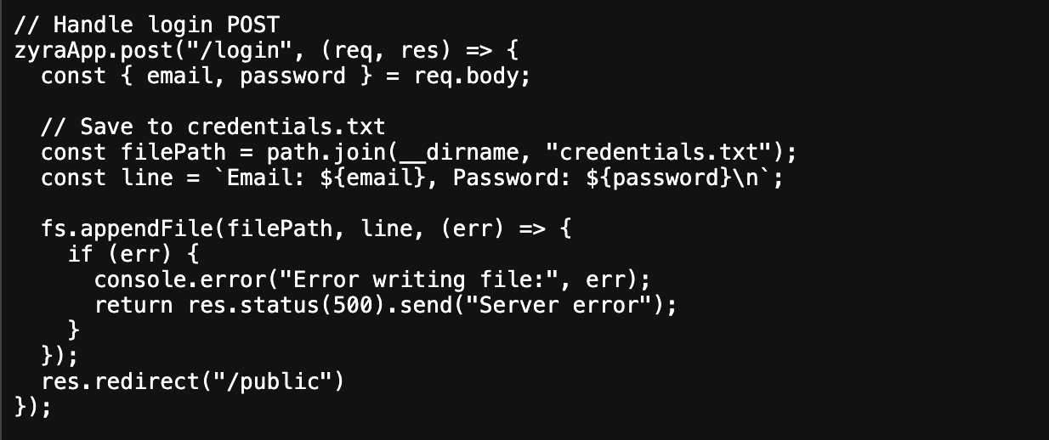
Figure 5 – Code fragment from server.js implementing the fraudulent login handler.

This snippet shows how the /login POST request takes the submitted email and password, appends them in cleartext to a local file credentials.txt, and then redirects the user to /public. No authentication is performed. This mechanism constitutes a credential-harvesting scam: users believe they are logging in, but their credentials are silently collected and stored.

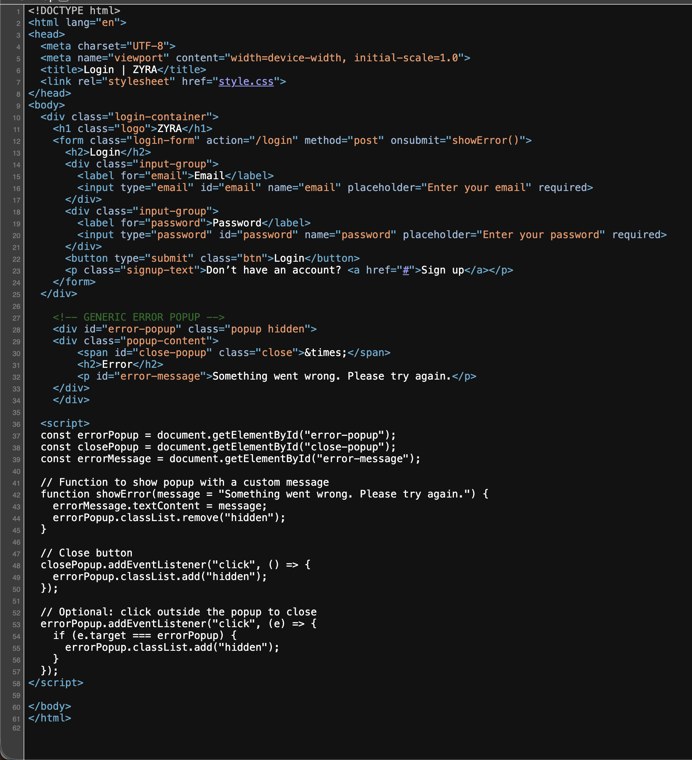
Figure 5 – HTML/JavaScript source of the login page.

This code shows the front-end of the fraudulent login page (login.html). It accepts an email and password, but instead of performing real authentication, it always triggers a generic error popup (Something went wrong. Please try again.). Combined with the backend handler (Figure 4), this demonstrates the scam workflow: credentials are captured and written into credentials.txt, while the user is misled into believing the login failed due to a generic error.

